**CBSE NATIONAL LEVEL SCIENCE EXHIBITION – 2018-19**

**Title: Blinds Partner**

**Under Theme: Scientific Solutions for Challenges in Life**

**Subtheme: Transport and Communication**

**Objective / Aim:** This idea of ours aims at helping blind people so that they can help themselves rather than taking help from others.

**Scientific Principle Involved:** SONAR sensor sends ultrasonic waves and catches back the reflected waves and comes to know the distance from any object so that he does not collides with anything.

IR transmitter sends the infrared light and the IR receiver receives it and makes the buzzer beep. This helps the blind person to find his stick if he had lost it.

LDR is a dark /light sensor which makes the LEDs glow in dim light and the LEDs do not glow when there is sufficient light in the surroundings. This helps the blind person to be visible in night to the other people.

When the two electrodes below come in contact with water the circuit completes and the stick starts vibrating due to a motor. This helps the blind person to come to know if there is water ahead.

**Material used:** PVC pipe, Glove, Arduino boards, SONAR sensors, Dark/Light sensor, LEDs, Motor, Electrodes, IR transmitter, IR receiver, Connecting Wires, power bank

**Working Investigation / Findings:** On the top of the stick, there is a dark /light LDR sensor that controls LEDs. Just below the LDR sensor there is an IR receiver. Then there is a circuit of Arduino controlling two of the SONAR sensors. One used for distance and other for the depth. At the bottom of the stick there are two electrodes.

The glove also has an Arduino board and a SONAR sensor.

**Approximate cost incurred and time spent:** Around Rs. 1800 and time 6 - 7 days

**Utility and further scope of the project :** This blind stick is made with an idea for helping peoplewith special needs .

• Blind people travelling independently rely on some form of external aids, which include a

variety of tools and techniques like a stick.

• It can be used by blind people in future as well as present.

• Specially the glove which we made is probably a very innovative idea.

**Books / Websites referred:** www.arduino.cc , http://arduino.create.cc , http://cicuitdigest.com

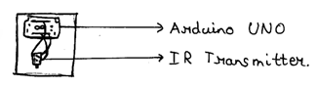**Figure/diagrammatic representation :** 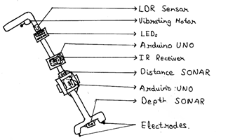

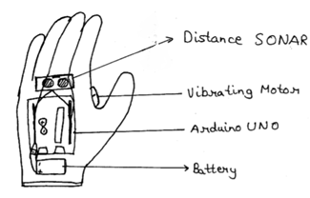

**Name of participants’** – a) Vivek Prakash

b) Kartik Bhatia

**Name of the Teacher Escort**: Sumit Rawal

**Contact No. of the Teacher Escort**: 9910044512

**Name of the school with the complete address**: Bhai Parmanand Vidya Mandir Surya Niketan, Anand Vihar, Pin Code: 110092, Delhi

Telephone No.: 011-22375373, 22377289, 41254346, 41254347

Email: [info@bvmschool.in](mailto:info@bvmschool.in)

**CBSE NATIONAL LEVEL SCIENCE EXHIBITION – 2018-19**

**REQUIREMENT FORM**

1. Name of the school with complete address and phone number:

Bhai Parmanand Vidya Mandir, Surya Niketan, Anand Vihar, Pin Code: 110092, Delhi.

Telephone No.: 011-22375373, 22377289, 41254346, 41254347

2. Please tick **‘yes’** or **‘no’** for the following requirements (tick as applicable):

i. Display Board Required - Yes( ✓)

ii. Water Source Required – No (🗶)

(if you wish to place the exhibit accordingly)

iii. Open space required - No (🗶)

(if sunlight for the model is needed)

iv. Exhibit size - Exhibit A – Normal Space

v. Poster/support material size - Exhibit A – Normal Space